**HOMEWORK 1**

**UML SOFTWARE MODELING ON WATER DISTRIBUTION, LEAKAGE AND QUALITY CONTROL SYSTEM (WCS)**

Group Members:

Aysel Yusubzada (ayusubzade@std.qu.edu.az)

Karthik Gopanna (karthikg691@gmail.com)

Stefan Ilić (stefan92f@yandex.com)

**UML Use Case Diagram**

Actors in the Use Case Diagram:

1. Chief Engineer
2. Technologist
3. Water Quality Monitor
4. Maintenance
5. Water Bill Management

**Chief Engineer**

The Chief Engineer can view necessary information recorded in the following two types of reports:

1. View Household Water Usage Reports – Access information stored in the Database by sending requests to the Controller and view reports of water requirement in the city.
2. View Internal System Reports – Access information about the quality of input water and water after each purification step.

**Technologist**

Water purification technologist - monitors the entire process – manages the purification process and also checks the quality of the water after its filtration. For the system to be working continuously, the Technologist must: obtain information about the initial state of water – input water for determining the concentration of harmful substances, control the disinfection process by determining the required chlorine dosage, obtain information about the state of water after filtration to determine the concentration of harmful substances, obtain information about the final state of water for comparison with the norms for potable water. The Technologist also manages the filtration process.

**Water Quality Monitor**

The Water Quality Monitor is responsible for checking the quality of the water at the end of each stage in the Purification process. S/he receives information about the final state of water, after which a decision is made to supply water to users. S/he checks the effluent water and decides whether it can be released out of the system.

**Maintenance**

Receive notifications about possible issues in the system – leak/block, states of the pipes, temperatures inside the pipes etc., submit reports after each notification, if necessary. S/he is also responsible for managing pipes in the entire system, add and/or remove pipes whenever it is needed for expansion of the distribution system.

**Water Bill Management**

Get information about water usage in the city by reviewing the water bills, generate reports and send them to the Database through the Controller.

**UML Component Diagram**

The main components identified are:

1. Controller System
2. Storage
3. User Interface
4. Pipe Management
5. Sensor Control
6. Purification

**Controller System**

The Controller System is responsible for the control and reliable functioning of the Water Management System. It contains the following sub-components:

1. Controller – The central component of the system that controls the behavior and functions of all the other components.
2. Report Generator – Component responsible for generating reports for the internal stakeholders (Chief Engineer, Maintenance personnel) to view, analyze and take actions.
3. External API – Provides an interface for Water Bill Management to communicate with the Storage sub-component, retrieve water usage data and generate bills for end users.

**Storage**

Contains the following two sub-components for managing and storing relevant data into the database:

1. Database Manager – Queries the database for information requested by other components.
2. Database – Collection of organized information related to the water management system.

**User Interface**

This component provides a graphical interface for the internal stakeholders (Chief Engineer, Maintenance personnel, Technologist and the Water Quality Monitor) to communicate with the Controller System. The stakeholders may perform various operations on the system based on information gathered from the Controller System.

The User Interface also notifies the concerned stakeholder about a pending issue or a resolution of an issue.

**Pipe Management**

The Controller instructs the Maintenance personnel to handle the pipe management – Add new pipes or remove old ones.

The Flow Control sub-component of the Pipe Management component is responsible for managing the flow of water through the pipes in the entire system.

**Sensor Control**

The Sensor Control component consists of two sub-components – Quality Monitor and Flow Monitor.

The Quality Monitor is responsible for calculating the quality of water based on these three factors – pH of water, Oxygen and Chlorine levels. These readings are obtained from three sensors which sense the pH, Oxygen and Chlorine level in the input water. The quality of water is then sent to the Controller System and then stored in the Database.

The Flow Monitor sub-component gathers data from two sensors – Leakage Sensor and Temperature Sensor, and a Water Meter to identify water consumption at the endpoints.

Leakage Sensors sense if there is any water leakage in the pipes based on pressure difference. The exact point of leakage can be identified using pressure sensors at each junction.

Temperature sensors are used in the purification process of water and to not let the water freeze due to weather conditions.

**Purification**

The Purification component consists of the Purification Controller sub-component which manages the water purification process. Input water undergoes four steps of purification – Filtration, Boiling, Disinfection and Reverse Osmosis. After each step, water is tested for its quality. Based on the results of the tests, certain parameters for the next purification process are modified.

**UML Sequence Diagram**

The UML Sequence Diagram consists of the following Use Cases:

1. Reports
2. Control Flow
3. Manage Pipes
4. Resolve Issues
5. Manage Purification Process
6. Receive Household Water Usage
7. Check Water Quality

**Reports**

Actor involved: Chief Engineer

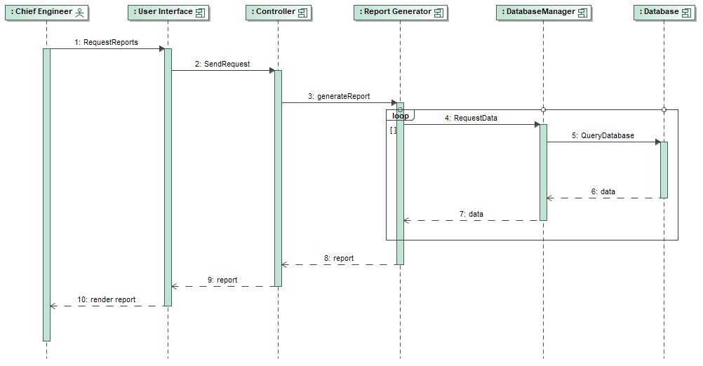

The Chief Engineer accesses the User Interface to request for reports. This request is sent to the Controller. The Controller then instructs the Report Generator to generate the required report. The Report Generator requests the Database Manager for relevant data for the report. This request is in a loop as multiple requests can be made. The requested data is returned from the Database and the Report Generator generates the required report in a human-readable form. This report is viewable by the Chief Engineer at the User Interface.

**Control Flow**

Actor involved: Maintenance

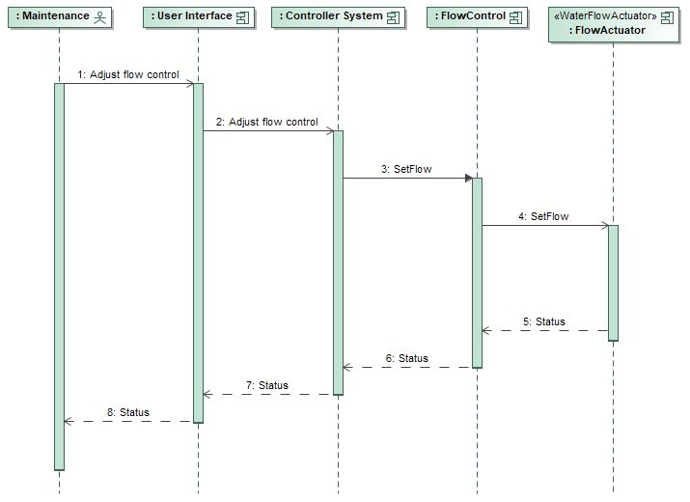

To control the flow of water through pipes, the Maintenance personnel sends a request to the Control System through the User Interface. This request is forwarded to the Flow Control sub-component which sets the Flow Actuator device to either increase or decrease the flow of water. The status corresponding to the operation is returned to the Maintenance personnel.

**Manage Pipes**

Actor involved: Maintenance

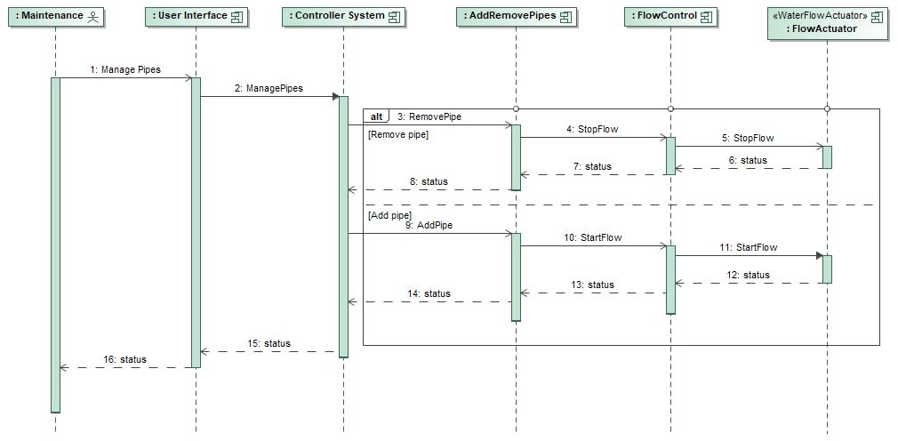

Maintenance personnel receives a notification on the User Interface to either add new pipes or remove old ones. The personnel then sends a request to the Pipe Management component through the Controller to adjust (either reduce or stop) the flow of water through the junction. The Flow Control sub-component of the Pipe Management component sets the Flow Actuator device to either reduce or stop the flow of water through the junction.

**Resolve Issues**

Actor involved: Maintenance

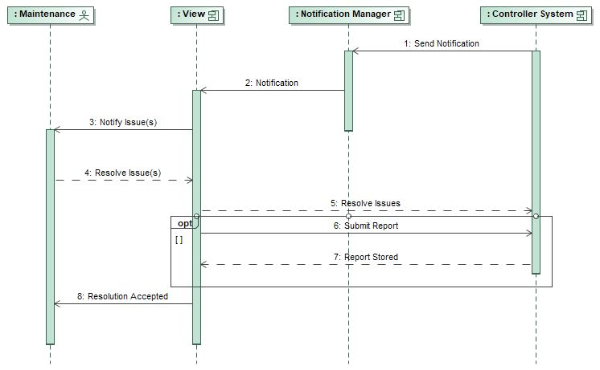

The Controller System sends notification about issues to the Notification Manager. The Maintenance personnel receives the notification and acts on the issue. The resolution of the issue is notified to the Controller System. Based on the criticality of the issue, the Maintenance personnel chooses to submit a report. After the Report has been stored in the Database, the Maintenance personnel receives a notification of the acceptance.

**Manage Purification Process**

Actor involved: Technologist

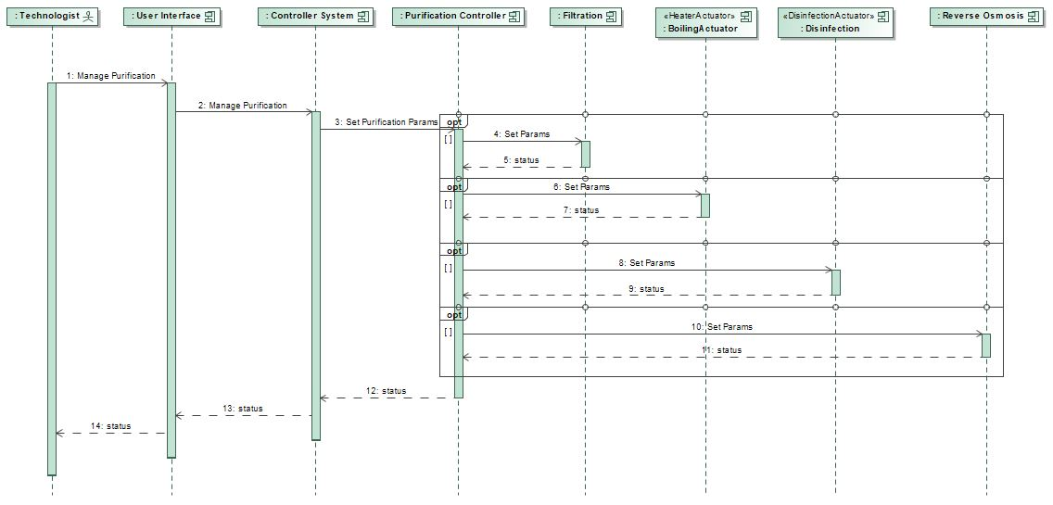

The Technologist manages the process of checking water quality and each step of water purification. S/he uses the User Interface to communicate with the Purification Controller to set parameters for the various stages of water purification – Filtration, Boiling, Disinfection and Reverse Osmosis. At the end of each step, status messages are sent to the Technologist.

**Receive Household Water Usage**

Actor involved: Water Bill Management

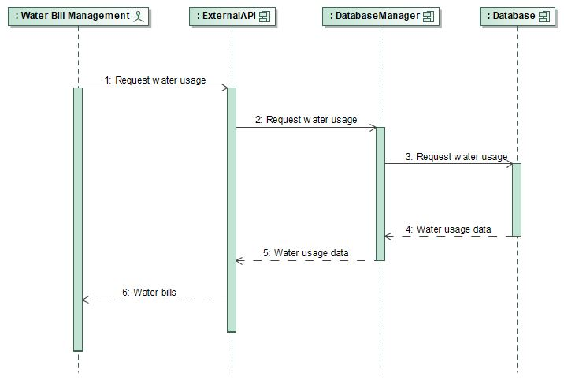

The Water Bill Management personnel communicate through an External API and request the Database Manager for water usage of the end-point (household or industry). The Database returns the Water Usage Data. The Water Bill Management personnel receive the final water bills from the External API.

**Check Water Quality**

Actor involved: Water Quality Monitor

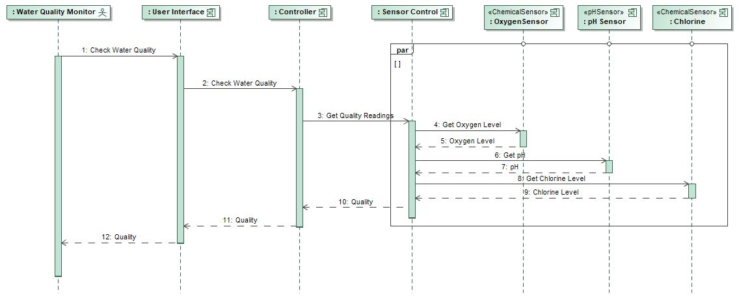

The Water Quality Monitor monitors and maintains the levels of minerals in the treated water under permissible levels. S/he calculates the quality of water based on the pH of water, Oxygen and Chlorine level in the water.

**UML Deployment Diagram**

The deployment diagram of the Water Management System consists of the following parts:

1. Sensor Control Server
2. Purification Server
3. User Interface
4. Main Server

**Sensor Control Server**

This server is tasked with continuously monitoring data gathered from the environment. Data is obtained through temperature, pressure, flow, pH and chemical sensors (oxygen and chlorine).

**Purification Server**

This server controls the process of purification. This is done through different actuators (Filtration, Boiling, Disinfection and Reverse Osmosis). Data to check results and to adjust filtration process is obtained through Sensor Control Server.

**User Interface**

The User Interface is deployed on various workstations enabling the internal stakeholders to interact with the water management system.

**Main Server**

The Main Server contains key business logic of the water management system. It coordinates action between different parts, stores data in the Database, generates reports and provides a back-end for client applications. Part of Main Server is also a Pipe Management service which handles addition of new pipe sections and/or removing old ones. The Main Server is also connected with flow control actuators spread through the pipe network enabling it to control water flow through the system.

The Water Management System consists of three different physical servers – Main Server, Purification Server and Sensor Control Server. These servers monitor, synchronize and control scalable number of different actuators and sensors in the water distribution network which enable the system to function properly.

**Actuators used:**

* Water Flow actuator
* Boiling actuator
* Disinfection
* Reverse Osmosis

**Devices:**

* Chemical sensor
* pH sensor
* Temperature sensor
* Pressure sensor
* Flow sensor
* Main Server
* Sensor Control Server
* Purification Server
* Workstation